Isaiah Narisma

Professor Underhill

MIS 484-6 (01) 42896

14 December, 2020

Cloud Infrastructure Deployment Reflection

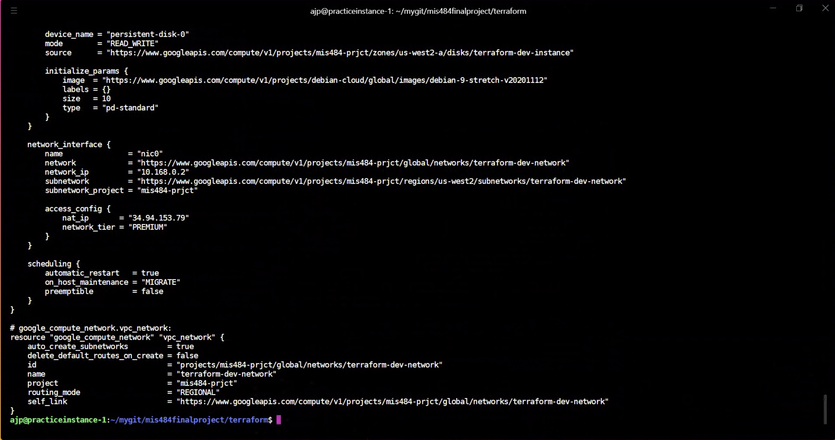

`terraform show` command

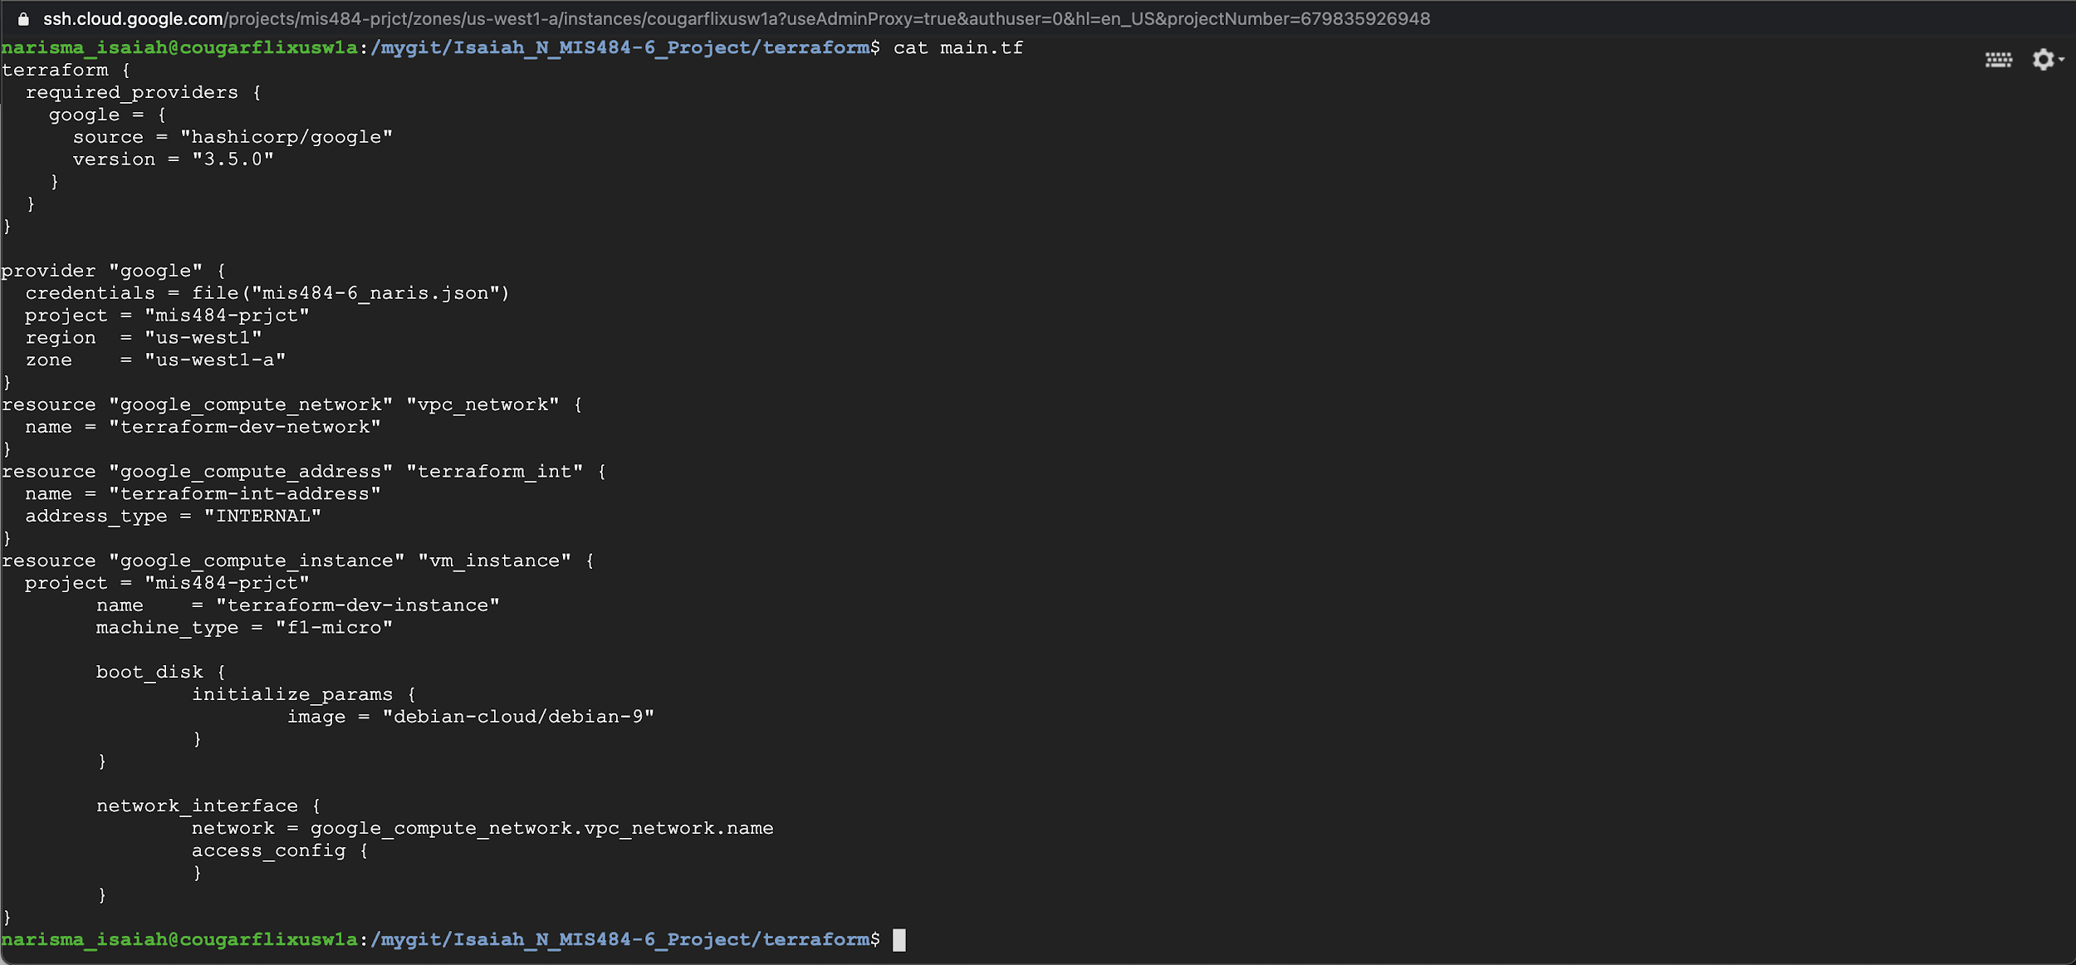

So this was a section of the `main.tf` terraform file that we made, taken from the example in your /captainarcher github repo and the infrastructure here is a GCP instance or AWS EC2 equivalent.

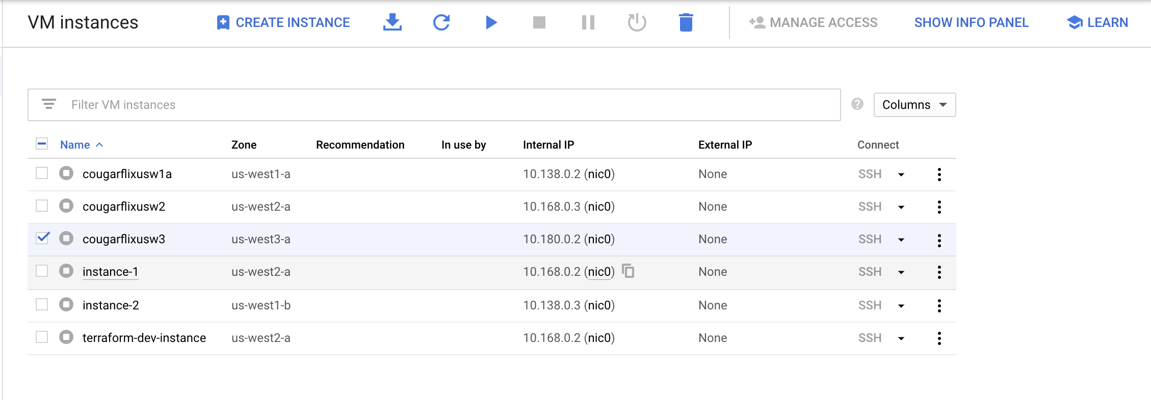

Here is a shot of all of my GCP instances that I had to create to complete this project because it would always give me that permission denied error from earlier, and in my AWS I had various IAM accounts with various roles attached, with VPCs, S3 buckets that I created earlier to be able to use in this project.

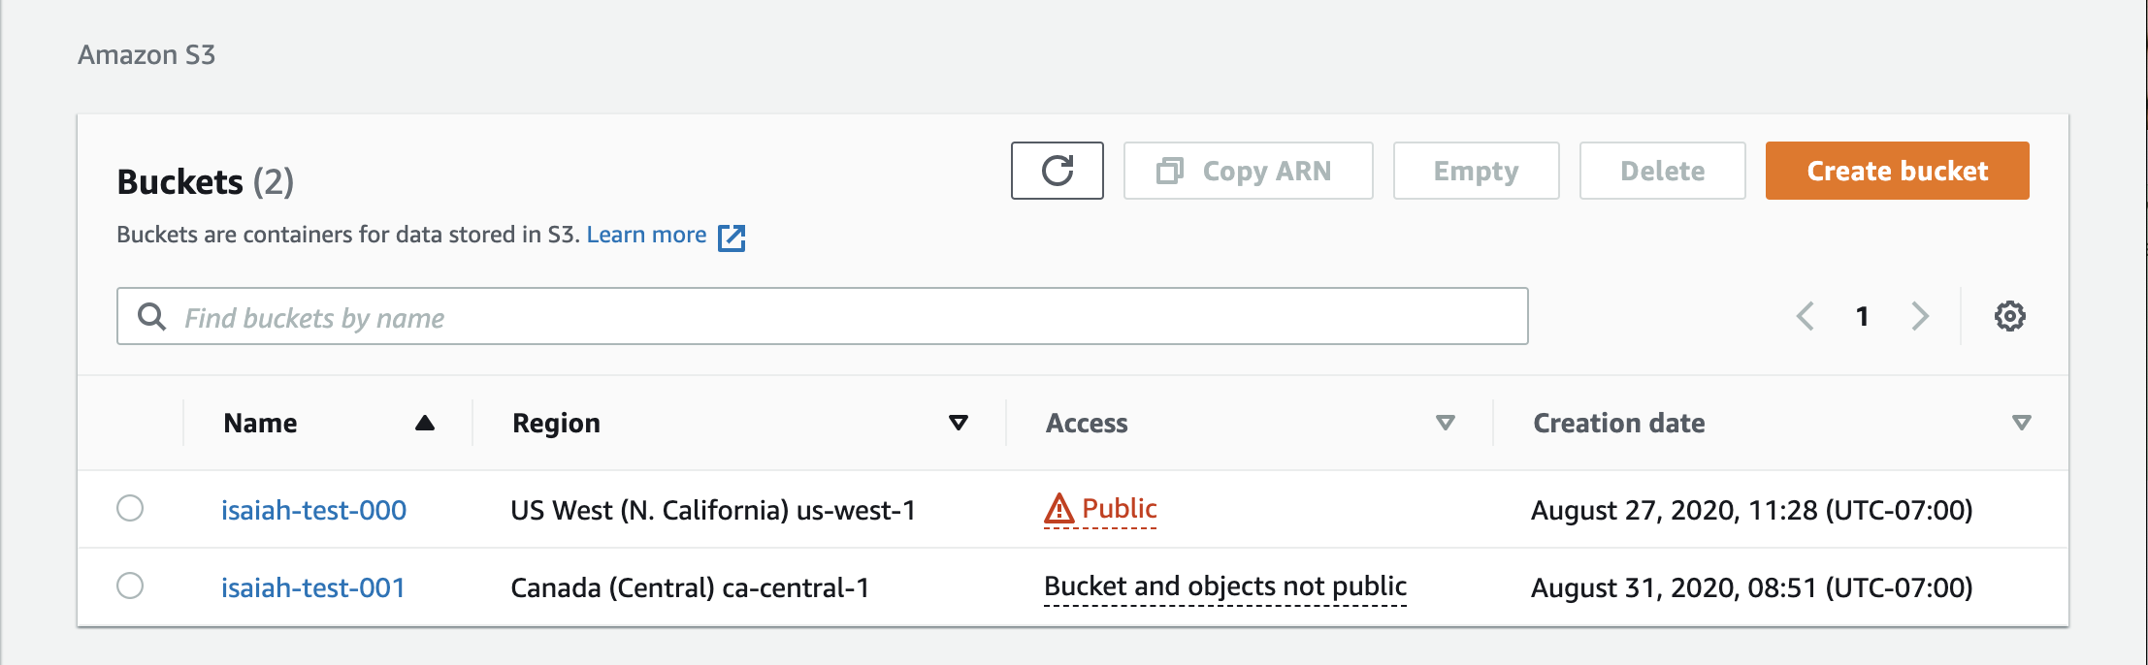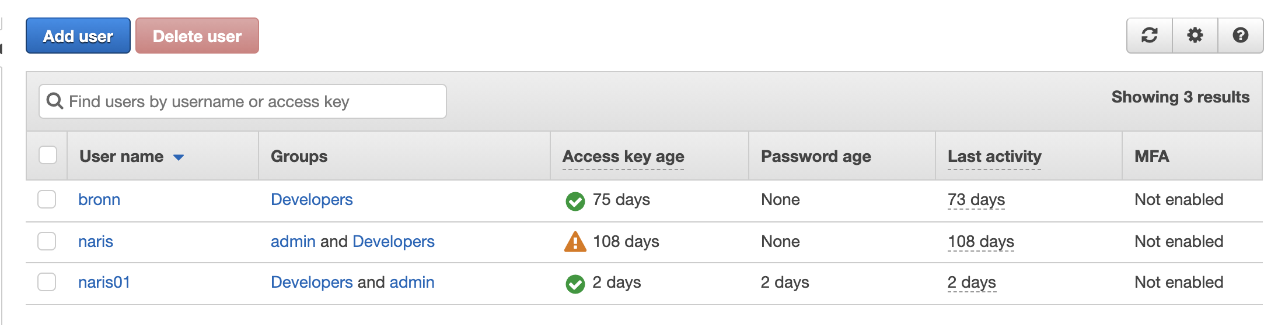

However, the problem I faced was being able to find those equivalent resources in GCP to use in this project.